Number theory
# Source: AI Source: Provided by: [Data Path: Persons Table -> ID Column: 1, Name_En Column: Motasem Essam] -> From: [ChatGPT] on [7/12/2026]
Number Theory is the branch of mathematics that studies the properties, relationships, and patterns of integers (whole numbers). It focuses on topics such as divisibility, prime numbers, factors, congruences, modular arithmetic, and Diophantine equations.
Often called the "Theory of Numbers" or the "Higher Arithmetic," number theory is one of the oldest branches of mathematics and plays an important role in modern cryptography, computer science, coding theory, and advanced mathematics.

Definition
# Source: AI Source: Provided by: [Data Path: Persons Table -> ID Column: 1, Name_En Column: Motasem Essam] -> From: [ChatGPT] on [7/12/2026]
Number Theory is the branch of mathematics concerned with the study of integers, their arithmetic properties, and the relationships between them.
Mathematically, number theory primarily studies numbers in the set
$$Z=\{…,-3,-2,-1,0,1,2,3,…\}$$
It investigates questions such as:
- Is a number prime or composite?
- What numbers divide another number exactly?
- How can integers be represented?
- What patterns exist among integers?
- Do certain equations have integer solutions?

Scope of Number Theory
# Source: AI Source: Provided by: [Data Path: Persons Table -> ID Column: 1, Name_En Column: Motasem Essam] -> From: [ChatGPT] on [7/12/2026]
Number theory studies topics including:
- Divisibility
- Prime numbers
- Composite numbers
- Factors and multiples
- Greatest Common Divisor (GCD)
- Least Common Multiple (LCM)
- Congruence (Modular Arithmetic)
- Divisibility tests
- Integer sequences
- Perfect numbers
- Deficient and abundant numbers
- Coprime (Relatively Prime) numbers
- Euler's Totient Function
- Diophantine equations
- Integer partitions
- Quadratic residues
- Continued fractions
- Cryptography
- Analytic Number Theory
- Algebraic Number Theory

Fundamental Concepts

1. Integers
# Source: AI Source: Provided by: [Data Path: Persons Table -> ID Column: 1, Name_En Column: Motasem Essam] -> From: [ChatGPT] on [7/12/2026]
Number theory mainly studies integers.
Examples:
$$-8, -3, 0, 5, 24$$

2. Divisibility
# Source: AI Source: Provided by: [Data Path: Persons Table -> ID Column: 1, Name_En Column: Motasem Essam] -> From: [ChatGPT] on [7/12/2026]
An integer $a$is divisible by another integer $b$if there exists an integer $k$such that
$$a=bk$$
Example:
$$24=6×4$$
Therefore,
$$6∣24$$

3. Prime Numbers
# Source: AI Source: Provided by: [Data Path: Persons Table -> ID Column: 1, Name_En Column: Motasem Essam] -> From: [ChatGPT] on [7/12/2026]
A prime number has exactly two positive divisors:
- 1
- Itself
Examples:
$$2, 3, 5, 7, 11, 13$$

4. Composite Numbers
# Source: AI Source: Provided by: [Data Path: Persons Table -> ID Column: 1, Name_En Column: Motasem Essam] -> From: [ChatGPT] on [7/12/2026]
Composite numbers have more than two positive divisors.
Examples:
$$4, 6, 8, 9, 12$$

5. Greatest Common Divisor (GCD)
# Source: AI Source: Provided by: [Data Path: Persons Table -> ID Column: 1, Name_En Column: Motasem Essam] -> From: [ChatGPT] on [7/12/2026]
The greatest integer dividing two or more numbers.
Example:
$$gcd⁡(18,24)=6$$

6. Least Common Multiple (LCM)
# Source: AI Source: Provided by: [Data Path: Persons Table -> ID Column: 1, Name_En Column: Motasem Essam] -> From: [ChatGPT] on [7/12/2026]
The smallest positive integer divisible by two or more numbers.
Example:
$$lcm⁡(12,18)=36$$

7. Modular Arithmetic
# Source: AI Source: Provided by: [Data Path: Persons Table -> ID Column: 1, Name_En Column: Motasem Essam] -> From: [ChatGPT] on [7/12/2026]
Studies remainders after division.
Example:
$$17 mod 5=2$$

8. Diophantine Equations
# Source: AI Source: Provided by: [Data Path: Persons Table -> ID Column: 1, Name_En Column: Motasem Essam] -> From: [ChatGPT] on [7/12/2026]
Polynomial equations whose solutions are restricted to integers.
Example:
$$x+y=10$$
Possible integer solution:
$$x=4,y=6$$

Examples
# Source: AI Source: Provided by: [Data Path: Persons Table -> ID Column: 1, Name_En Column: Motasem Essam] -> From: [ChatGPT] on [7/12/2026]
Example 1
Determine whether 29 is prime.
Since its only positive divisors are
$$1, 29$$
29 is a prime number.

Example 2
Find the GCD.
$$gcd⁡(42,56)=14$$

Example 3
Find the LCM.
$$lcm⁡(15,20)=60$$

Example 4
Find the remainder.
$$38 mod 7=3$$

Example 5
Determine divisibility.
Since
$$54=6×9$$
then
$$6∣54$$

Example 6
Find prime factors.
$$84=2^{2}×3×7$$

Major Branches of Number Theory
# Source: AI Source: Provided by: [Data Path: Persons Table -> ID Column: 1, Name_En Column: Motasem Essam] -> From: [ChatGPT] on [7/12/2026]
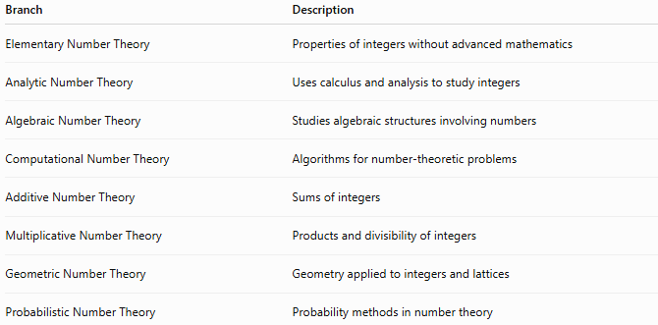
Branch | Description
Elementary Number Theory | Properties of integers without advanced mathematics
Analytic Number Theory | Uses calculus and analysis to study integers
Algebraic Number Theory | Studies algebraic structures involving numbers
Computational Number Theory | Algorithms for number-theoretic problems
Additive Number Theory | Sums of integers
Multiplicative Number Theory | Products and divisibility of integers
Geometric Number Theory | Geometry applied to integers and lattices
Probabilistic Number Theory | Probability methods in number theory

Important Theorems
# Source: AI Source: Provided by: [Data Path: Persons Table -> ID Column: 1, Name_En Column: Motasem Essam] -> From: [ChatGPT] on [7/12/2026]
Some famous results include:
- Euclid's Theorem on infinitely many primes
- Fundamental Theorem of Arithmetic
- Fermat's Little Theorem
- Euler's Theorem
- Chinese Remainder Theorem
- Wilson's Theorem
- Bézout's Identity
- Euclidean Algorithm
- Quadratic Reciprocity Theorem

Real-Life Applications
# Source: AI Source: Provided by: [Data Path: Persons Table -> ID Column: 1, Name_En Column: Motasem Essam] -> From: [ChatGPT] on [7/12/2026]
Number theory is used in:
- Cryptography
- Cybersecurity
- Computer science
- Coding theory
- Error detection
- Error correction
- Digital communications
- Data encryption
- Blockchain technology
- Mathematics research

Real-Life Examples
# Source: AI Source: Provided by: [Data Path: Persons Table -> ID Column: 1, Name_En Column: Motasem Essam] -> From: [ChatGPT] on [7/12/2026]
1. Internet Security
RSA encryption relies on prime numbers and modular arithmetic.

2. Banking
Secure online banking uses number theory in encryption protocols.

3. Digital Signatures
Electronic signatures use modular arithmetic and prime factorization.

4. QR Codes
Error-correcting codes used in QR codes are based on number-theoretic concepts.

5. Satellite Communication
Number theory helps detect and correct transmission errors.

6. Computer Algorithms
Algorithms for finding GCDs and prime numbers rely on number theory.

7. Blockchain
Cryptocurrencies use modular arithmetic and elliptic curve mathematics.

8. Password Security
Public-key cryptography uses prime numbers and modular arithmetic to protect passwords.

Common Mistakes
# Source: AI Source: Provided by: [Data Path: Persons Table -> ID Column: 1, Name_En Column: Motasem Essam] -> From: [ChatGPT] on [7/12/2026]
- Confusing factors with multiples.
- Assuming every odd number is prime.
- Forgetting that 1 is neither prime nor composite.
- Mixing up GCD and LCM.
- Confusing remainder with quotient.
- Assuming every equation has integer solutions.

Key Points
# Source: AI Source: Provided by: [Data Path: Persons Table -> ID Column: 1, Name_En Column: Motasem Essam] -> From: [ChatGPT] on [7/12/2026]
- Number theory studies integers.
- Prime numbers are fundamental building blocks of integers.
- Divisibility is a central concept.
- Modular arithmetic studies remainders.
- The Fundamental Theorem of Arithmetic guarantees unique prime factorization.
- Number theory has major applications in cryptography and computer science.

Arithmetic vs. Number Theory
# Source: AI Source: Provided by: [Data Path: Persons Table -> ID Column: 1, Name_En Column: Motasem Essam] -> From: [ChatGPT] on [7/12/2026]
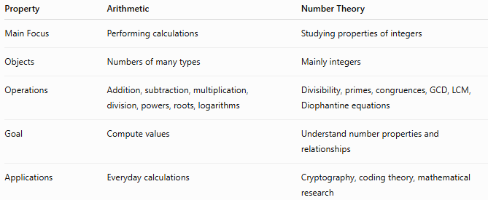
Property | Arithmetic | Number Theory
Main Focus | Performing calculations | Studying properties of integers
Objects | Numbers of many types | Mainly integers
Operations | Addition, subtraction, multiplication, division, powers, roots, logarithms | Divisibility, primes, congruences, GCD, LCM, Diophantine equations
Goal | Compute values | Understand number properties and relationships
Applications | Everyday calculations | Cryptography, coding theory, mathematical research

Conclusion
# Source: AI Source: Provided by: [Data Path: Persons Table -> ID Column: 1, Name_En Column: Motasem Essam] -> From: [ChatGPT] on [7/12/2026]
Number Theory is the mathematical study of integers and their properties. It explores concepts such as divisibility, prime numbers, modular arithmetic, greatest common divisors, least common multiples, and integer equations. As one of the oldest and deepest areas of mathematics, number theory provides the theoretical foundation for modern cryptography, secure communication, computer science, and many advanced mathematical disciplines.

